

**GREATER TZANEEN MUNICIPALITY**

**GROTER TZANEEN MUNISIPALITEIT**

**MASIPALA WA TZANEEN**

**MASEPALA WA TZANEEN**

Tropical Paradise

P.O. BOX 24 **TEL:** 015 307 8000

TZANEEN  **FAX:** 015 307 8049

0850

***www.tzaneen.gov.za***

______________________________________________________________

**SCHEDULE OF SERVICE DELIVERY STANDARDS TABLE**

**COMMUNITY SERVICES DEPARTMENT**

**ENVIRONMENTAL HEALTH SERVICES**

|  |
| --- |
| 1. Approval of building plan   **1 Day** |
| 1. Complaint investigation   **2 Days** |
| 1. Issuing of Certificate of Competence for mortuaries   **1 Month** |
| 1. Approval of on-site- waste management plan.   **14 days** |
| 1. Review and comment on Basic Assessment Report.   **21 days** |

**SOLID WASTE REMOVAL**

|  |
| --- |
| 1. Premise based removal (Residential Frequency) |
| 1. Premise based removal (Business Frequency) |
| 1. Bulk Removal |
| 1. Removal Bags provided (Yes/No) |
| 1. Garden refuse removal included (Yes/No) |
| 1. Street Cleaning Frequency in CBD |
| 1. Street Cleaning Frequency in areas excluding CBD |
| 1. How soon are public areas cleaned after events (24hours/48hours/longer) |
| 1. Clearing of illegal dumping (24 hours/48hours/longer) |
| 1. Recycling or environmentally friendly practices (Yes/No) |
| 1. Licensed landfill site (Yes/No) |

**LICENSING SERVICES**

|  |
| --- |
| 1. How long does it take to register a vehicle? (minutes)   **10 Minutes per transaction** |
| 1. How long does it take to renew a vehicle license? (minutes)   **10 Minutes per transaction** |
| 1. How long does it take to issue a duplicate registration certificate vehicle? (minutes)   **10 Minutes per transaction** |
| 1. How long does it take to de-register a vehicle? (minutes)   **10 minutes for application and the approval part lies within the Provincial helpdesk** |
| 1. How long does it take to renew a drivers license? (minutes)   **15 Minutes** |
| 1. What is the average reaction time of the fire service to an incident? (minutes)   **Disaster** |
| 1. What is the average reaction time of the ambulance service to an incident in the urban area? (minutes) |
| 1. What is the average reaction time of the ambulance service to an incident in the rural area? (minutes) |

**LIBRARY SERVICES**

|  |
| --- |
| 1. Checking in of library item   **2 Minutes** |
| 1. Checking out of library item   **2 Minutes** |
| 1. Registering membership   **10 Minutes** |
| 1. Assisting with finding project information   **10 Minutes** |

**WASTE DIVISION**

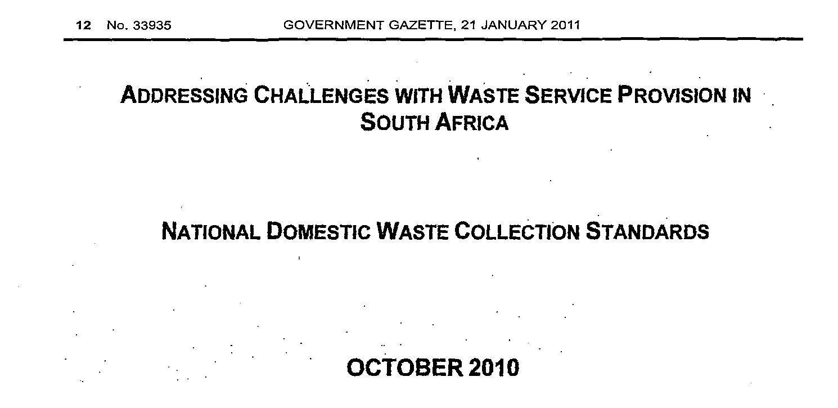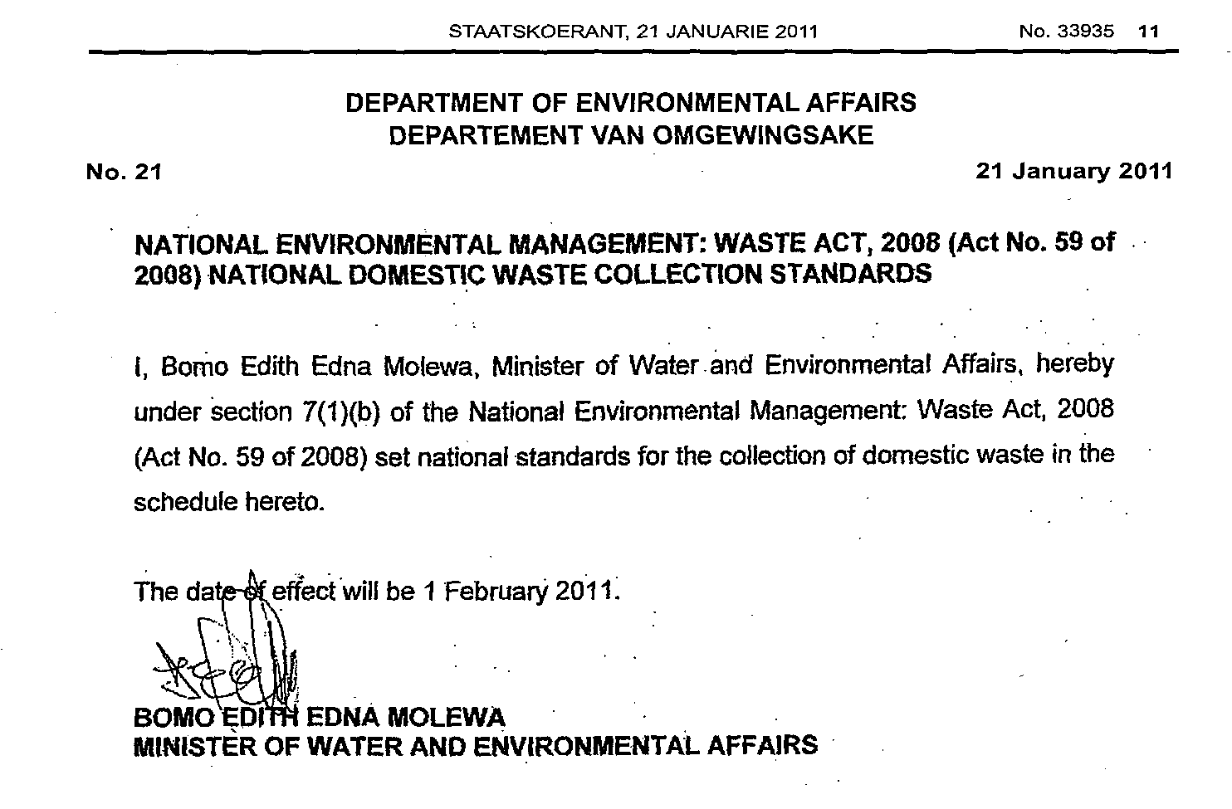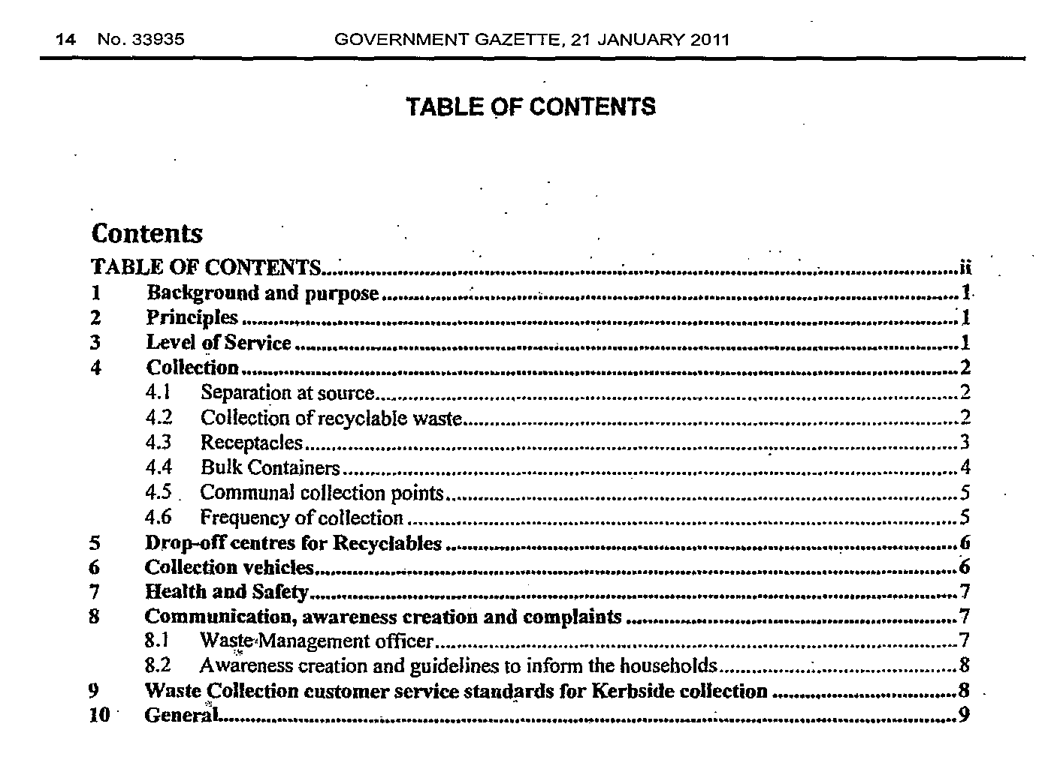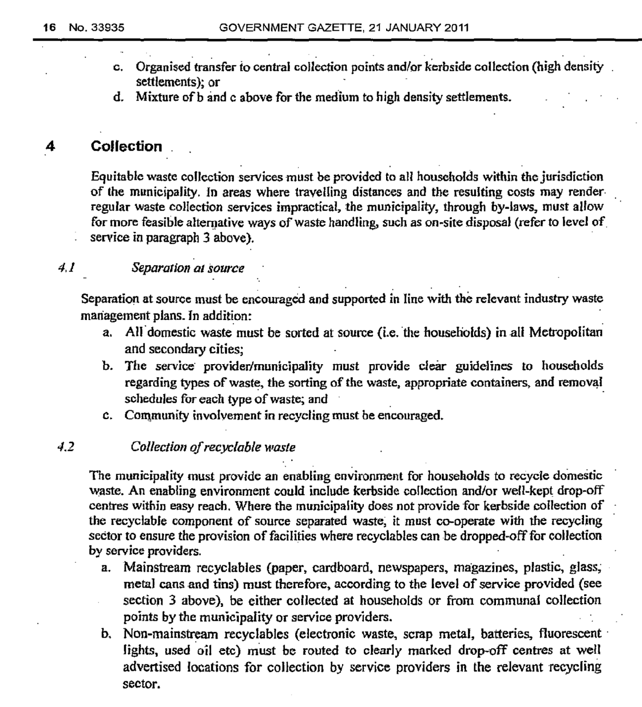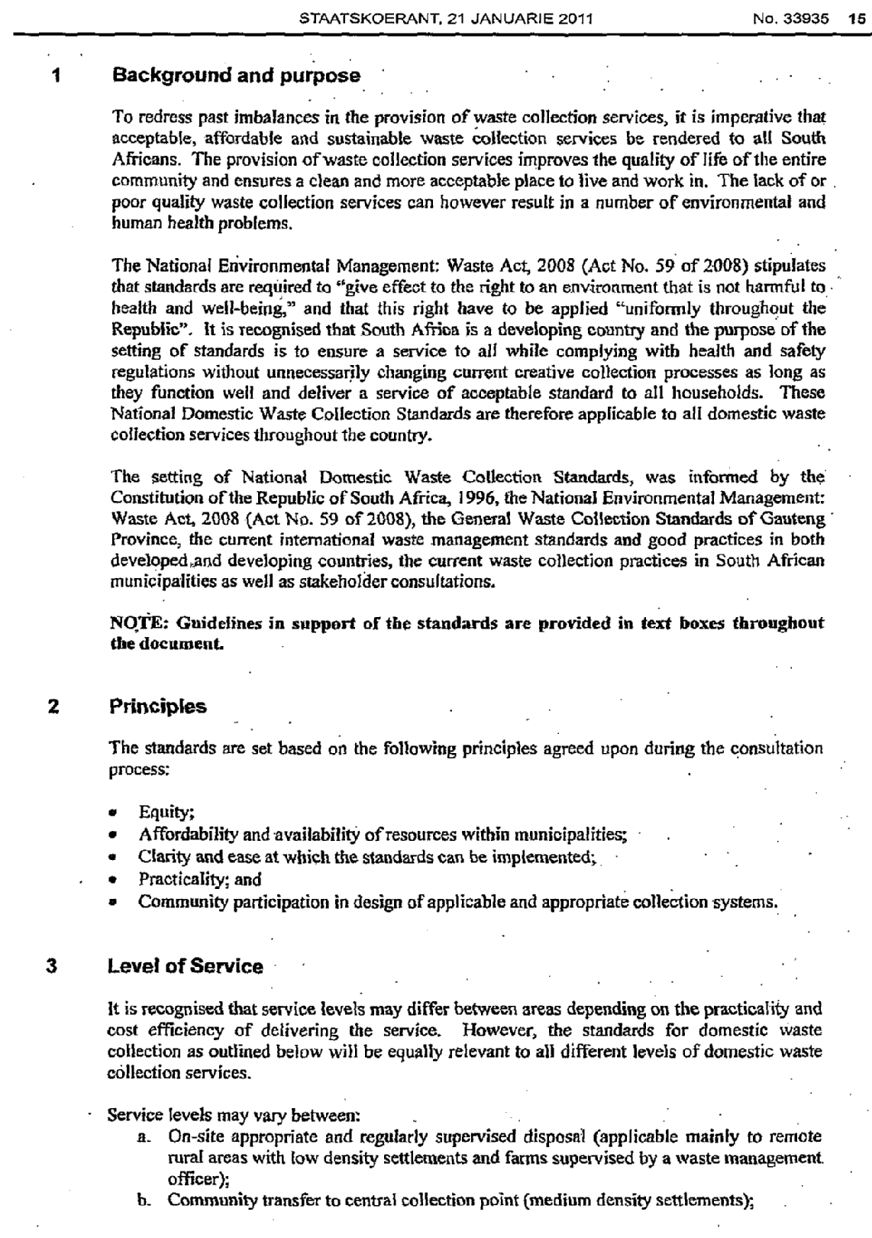

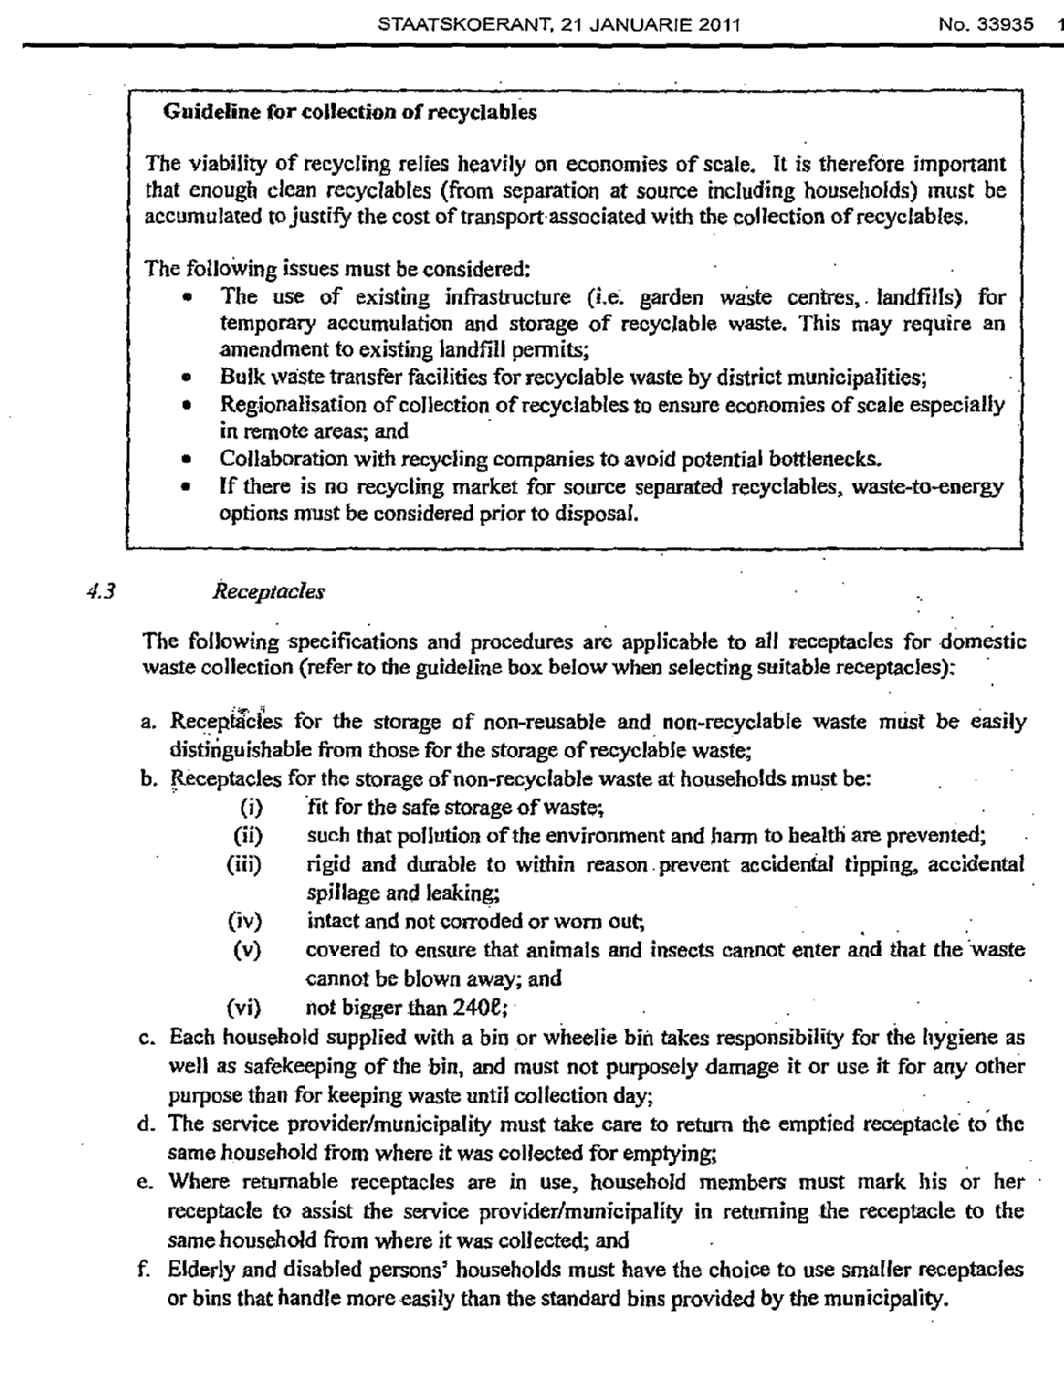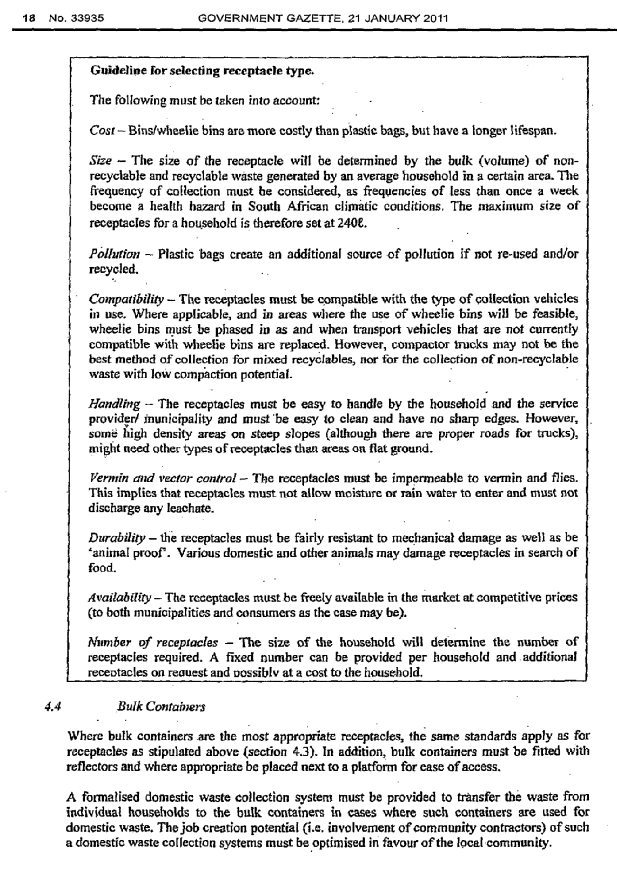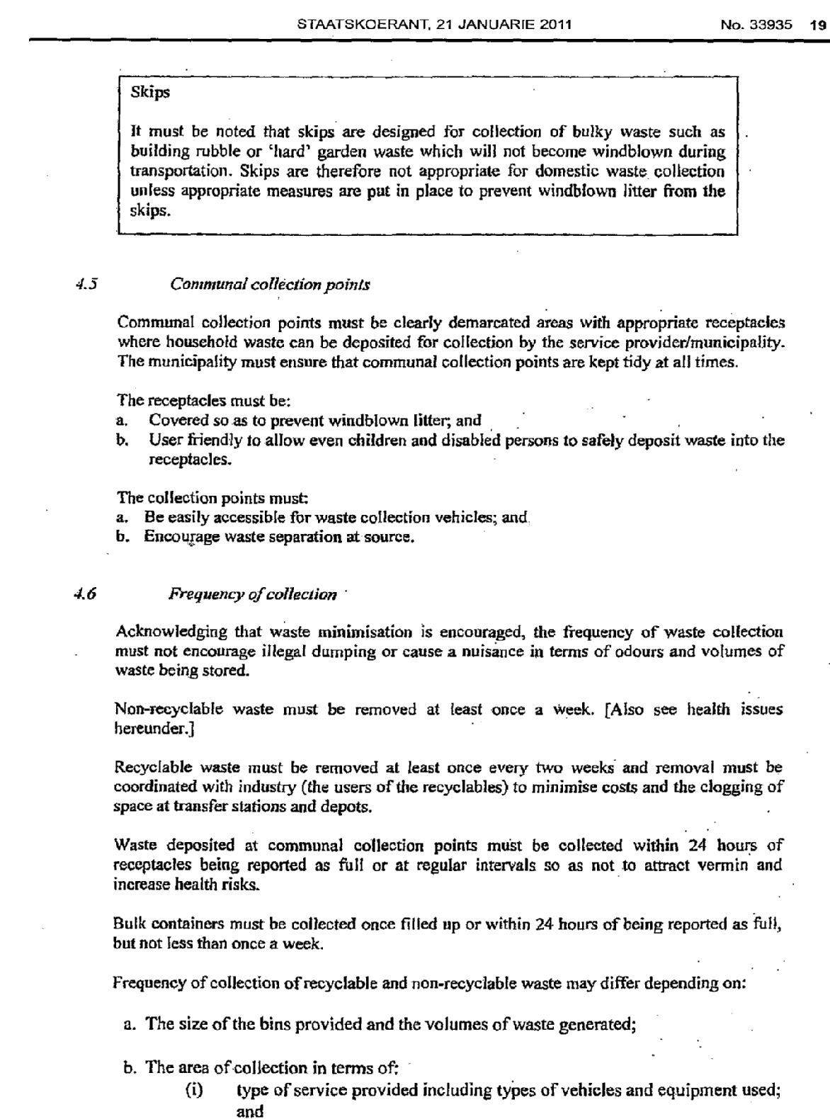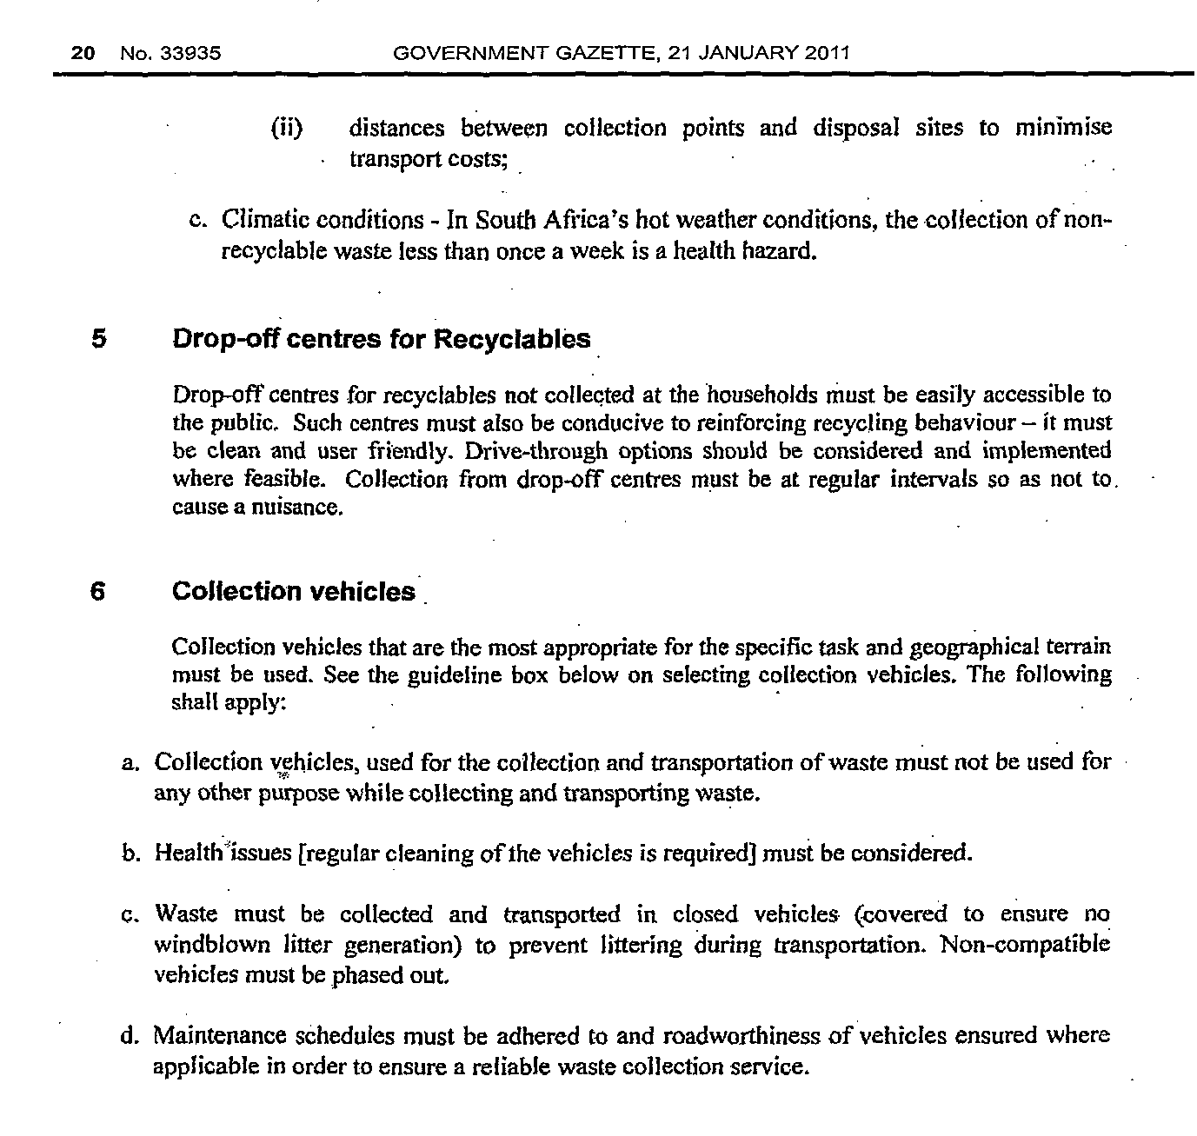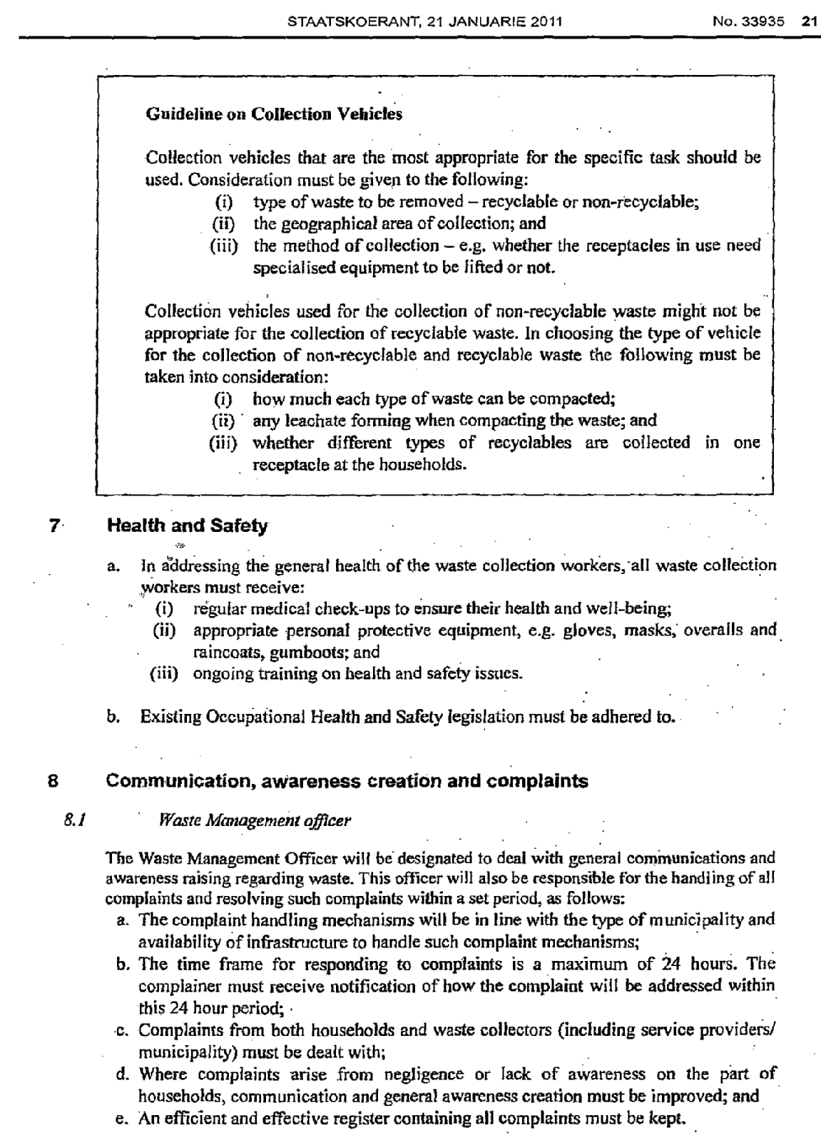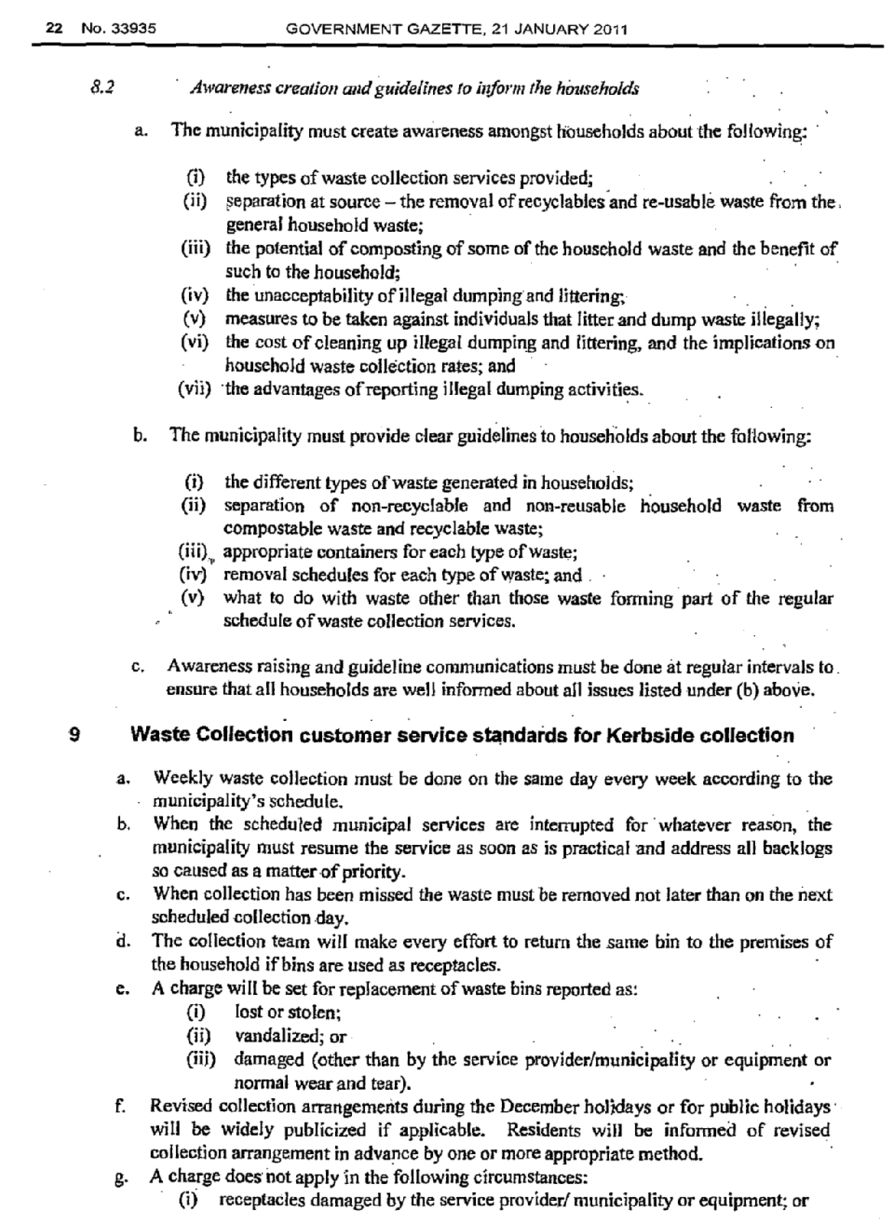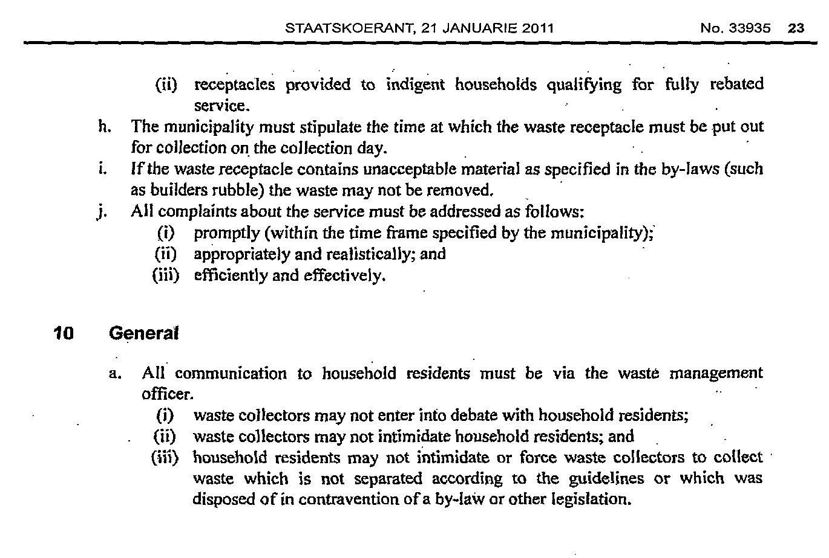

**SAFETY AND SECURITY DIVISION**

1. Conducted Crime Awareness Campaigns once per quarter.

2. Crime Prevention Against Theft of Council  Assets - daily.

3. Community Safety Forum held the Safety and Security Colloquium.

4. Developed Annual Safety Audit

5. Developed Annual Community Safety Plan

6. Maintenance of Access Control Gates ( Morpho) monthly

7. Plan for Joint Opetations Centre for Municipal Events - weekly and as and when needed.